**TABLE OF CONTENTS**

**SECTION PAGE**

1 Scope 2

1.1 Sitemap 2

2 wireframe 3

2.1 Login Page 4

2.2 Home/Dashboard Page 5

2.3 Projects 7

2.4 {Project Name} – {Component name} 8

2.5 {Detailed Graph} 10

2.6 Data Management 11

2.7 Assets 12

2.8 profile 13

2.9 Help 14

2.10 Admin 15

2.11 Site Map 16

# Scope

To create a wireframe and site map for Data Management Software (DMS) and to explain a detail description of the page and functionalities within each pages.

## Sitemap



Figure 1: Site Map

# wireframe

Wireframe is a page schematic or screen blueprint, is a visual guide that represents the skeletal framework of a website.

**Site map structure:**

## Login Page



Figure 2: Login page

Username and password are checked from the database table, once both values are verified by the software will provides access. Only admin will have privilege and provide username and password to the user, this event will be done on Admin – User Management page. Since there is not a register page, all the access is to set by Admin.

This featured will be linked up using LDAP to maintain user sessions.

## Home/Dashboard Page



Figure 3: Home/Dashboard page

User (Admin/Client/Engineer) only sees div (box) areas which they have permission to access. On hover or click over ‘profile’, ‘help’, ‘admin’ pop-up list appears with list of functionalities.

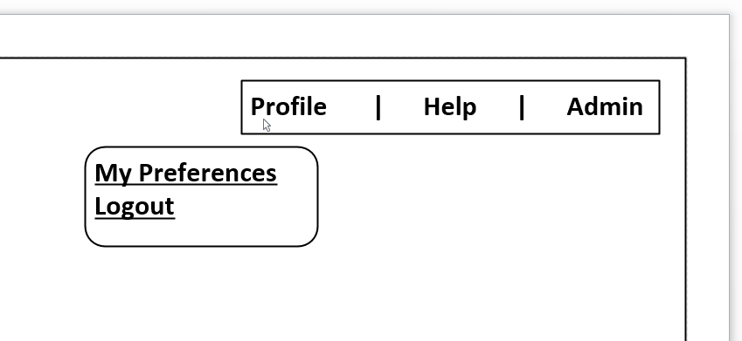

Figure 4: On-click on profile link

Table 1: List of links

|  |  |  |  |
| --- | --- | --- | --- |
| **Profile** | **Help** | **Admin** | **Access** |
| My Preferences (A,C,E) | Documentation (A,C,E) | Administration (A) | A – Admin  C – Client  E – Engg |
| Logout (A,C,E) | Videos (A,C,E) | User management (A) |
|  | Site Map (A,C,E) |  |
|  | Support (A,C,E) |  |
|  | About US (A,C,E) |  |

All the sub links are directed to main link;

For example: when user click **Notifications** links under the main link **Assets**, the link should direct to **Assets** page, same with other sub links under **Data Management** and **Projects**.

**Project Status:**

In this div list of projects (previously stored projects on the database) will be displayed, when user clicks the project link will be directed to {Project Name}-{Component name} page

**Monthly Reports:**

The most recently created or user working on reports are shown in this div from the database, if user click on the project report link will be directed to {Project Name} – {Report View} page

**Recent Projects:**

In this div, will show the list of projects (for now, this div will have same as Project Status div)

**User Activities:**

Detailed tracking of user actions, such as which user is connected, which project user is engaged, this div will be shown only to the Admin.

**Menu navigation:**

**Projects:**

When user clicks on this link and sub link (List of projects) will be directed to Projects page where list of projects are fetched from database and displayed

**Data Management:**

When user clicks on this link will be directed to Data management page where the datalog file will be imported to the database

**Assets:**

When user clicks on this link will be directed to Asset page where all the projects listed out with corresponding items such as Notifications, Warranties, Licenses, Maintenance Contracts

## Projects



Figure 5: Projects

List of project link will bring into this page which shows list of all projects

Example-1: List of project view

|  |  |  |  |  |  |  |
| --- | --- | --- | --- | --- | --- | --- |
| **Ref** | **Name** | **Customer** | **Manager** | **Status** | **Start date** | **End date** |
|  |  |  |  |  |  |  |
|  |  |  |  |  |  |  |
|  |  |  |  |  |  |  |

This page will be displayed all the projects from the database. When user clicks on the particular project will to directed to {Project Name} - {Component name} page

## {Project Name} – {Component name}



Figure 6: {Project Name} – {Component name}

**Graph (div or Java plot API’s):**

Each project has one component. Each component will have corresponding datalog file, using that data, a graph will be produced and displayed. The graph will be plot based two columns (1st and 6th), 1st column is date&time and 6th column is the readings.

**Component IR Value (div):**

On this div, maximum value, minimum values, Average value, Overall values are shown in this.

**Events:**

Datalog files carry information’s such as time of start, time of stop, component switched off, component restarted and so on, and these values (status) are shown in this div

**Analysis:**

If there are any remarks will be shown in this div

**List of projects:**

In this div, a shorter version of list of projects are shown here, so that user doesn’t have come from beginning.

## {Detailed Graph}



Figure 7: {Project Name} – {Report View}

This page is continuation of previous page ({Project Name} – {Component name}), if user wants see full page graph then by clicking a button link will bring to this page

**Import:** Button will be placed without any action

**Export:** Button will be placed without any action

**Trending:** Button will be placed without any action

**Reports:** Button will be placed without any action

**Fault Prediction:** Button will be placed without any action

## Data Management



Figure 8: Data Management

**File selection:**

In this div, on click file directory will be displayed wherein user selects and upload it to the database.

* At first user have to register the entry in the database, if it is a new project.
* If the project already exist in the database, the import function should upload only the new entries.

Example: 1

|  |
| --- |
| Column 1 |
| 2013-11-19T10:51:46 |
| … |
| 2013-11-20T03:30:46 |

* The datalog file always will have from starting date to recent date (the date of file is downloaded), the above example shows first 1000 entries (1 – 1000 data)

Example: 2

|  |
| --- |
| Column 1 |
| 2013-11-19T10:51:46 |
| … |
| 2013-12-04T19:28:46 |

* The second example of datalog file (belongs to the same project) have an entry (1 – 2500 data) but first 1000 entries is already present in the database, so import functionalities should have an intelligence to upload from 1001 – 2500 data to the database.

## Assets



Figure 9: Assets Page

This Asset page will list all the project with corresponding items which is associated with it

Example-1: Asset page view

|  |  |  |  |  |  |  |  |  |  |
| --- | --- | --- | --- | --- | --- | --- | --- | --- | --- |
| **Ref** | **Name** | **Customer** | **Status** | **Start** | **End** | **License** | **Notification** | **Warranties** | **Maintenance Contracts** |
|  |  |  |  |  |  |  |  |  |  |
|  |  |  |  |  |  |  |  |  |  |

## profile



Figure 10: Profile Page

This profile page should be an empty page (dummy page, may be details are filled by the company)

## Help



Figure 11: Help Page

This help page should be an empty page (dummy page, may be details are filled by the company)

## Admin



Figure 12: Admin Page

This Admin page should be have list of user to modify, add new user and delete user.

## Site Map



Figure 13: Site Map page

This sitemap page should be an empty page (dummy page, may be details are filled by the company)